**Descriptive Analytics and Visualisations**

**(Analysis of car insurance brokerage services)**

1. Introduction

The Finance Review magazine wants to see a rise in the number of businesses providing vehicle insurance brokerage services and what this can mean for customers. In order to find his or her clients the best possible policies, an insurance broker is an independent insurance representative who works with numerous insurance providers. The majority of these brokers claim to be able to save car owners hundreds of dollars annually on insurance costs.

The objective of this analysis is that I have to performed an exploratory analysis on the dataset file A1.xlsx. We observe that dataset consist of a random sample of 400 customers who obtained the services of car insurance brokers.

A1.xlsx file consist 12 variables. The description of the dataset is shown below as:

|  |  |
| --- | --- |
| **Variable Name** | **Description** |
| Gender | Gender of the respondent {Male; Female} |
| Age_Driver | Age of the Driver |
| State | State where customer resides {NSW; VIC; QLD; SA; WA; TAS; NT; ACT} |
| Area | Area classification {Urban; Rural} |
| NCBR | No claim bonus rating {None; Silver; Gold; Platinum; Ruby; Sapphire; Diamond} |
| Val_Method | Valuation Method {Agreed Value; Market Value} |
| Veh_Type | Vehicle Type {4WD; Family; Luxury; Sports} |
| Broker | Car Insurance Broker {yChoose; iChoose; uChoose; vChoose} |
| Insurer | Insurance Policy Provider {AAMI; Allianze; Coles; GIO; NRMA; RACV; Youi} |
| Approched_Insurer | Approched current insurance provider for a better deal before contacting broker{ Yes; No} |
| Customer_Sat | Level of satisfaction with Insurance Broker {Very Satisfied; Satisfied; Dissatisfied; Very Dissatisfied} |
| Savings | Annual saving on car insurance premium in dollars |

2. Main Body or Data Analysis

In this section, we are going to analysis the dataset or answer to the case study and questions asked by Edmond.

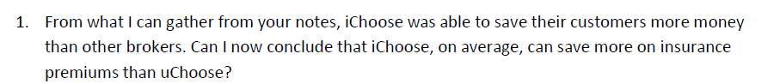

The below bar chart shows that

Alternatively, we can simply plot the pie chart which shows the percentage of the broker who save more on insurance premium.

The bar charts shows that the how much broker save their customers money, while the pie chart demonstrates that the what percentage of broker save their customer money. We observe that broker “iChoose” bar height is highest as compare to other broker, while the lowest height of the bar is broker “vChoose”.

Thus, we can easily conclude that the “iChoose” was able to save their customers more money than other brokers. Also, “iChoose”, on average, can save more on insurance premiums than “uChoose” that is 49,864 > 16,621.

2.

